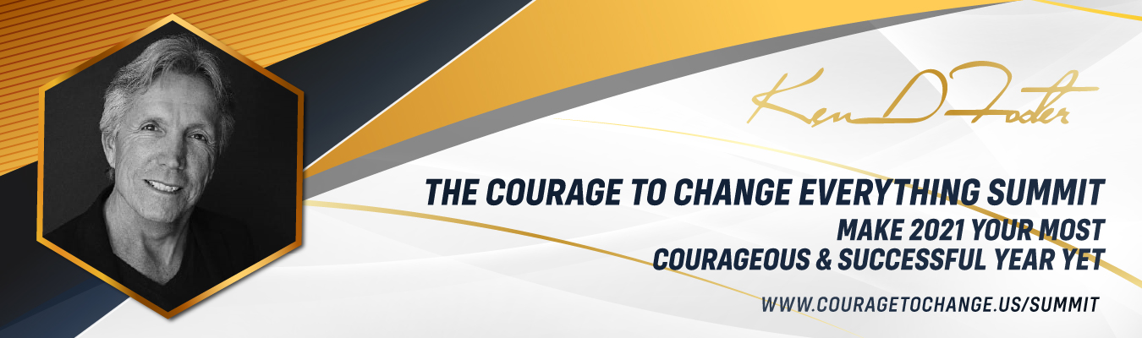
Will 2021 Be Your Best Year Ever or a Repeat of 2020?

Hi (Your Name) here,
We all went through a lot last year, but believe it or not, if you choose to clear out the past, reprogram your thinking a little, and have the right vision, it is possible for you to have your greatest year ever in 2021 and beyond.
To that effect, I have created a Summit called: The Courage to Change Everything Virtual Summit At the Summit you will be connecting with 30 wise and courageous Leaders, who are experts in their fields and committed to supporting you in up-leveling your business and life in 2021.
There is no charge for General Admission and I highly recommend you download the free eBook called The Energetic Clearing Technique™ when you register. It will help you clear any past disempowering beliefs, choices and actions that have kept you from generating your greatest dreams and being the best version of yourself. It is truly an empowering experience.
In the book, Ken D Foster shows you how to get rid of stubborn habits that you have tried to change, possibly for years. It happens naturally, because you are releasing the illusions, delusions and emotions that have kept you from connecting with your true self. In fact, you may feel so empowered that you may have difficulty accepting that the change has actually happened. Then one day you’ll look back and realize that the day you completed the Energetic Clearing Technique™ was the day your destiny changed forever.
If you are ready to have 2021 be your greatest year ever and generate more health, wealth, and happiness, I encourage you to register for the Courage to Change Everything Summit and get your copy today. Remember there is no charge for General Admission, although seating is limited.
Click here to receive the Energetic Clearing Technique™ eBook and get into the Courage Zone.
With Courage,
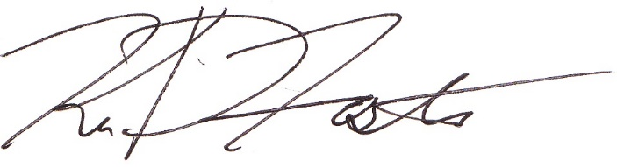
Ken D Foster
Best-Selling Author
Host Voices of Courage Show

