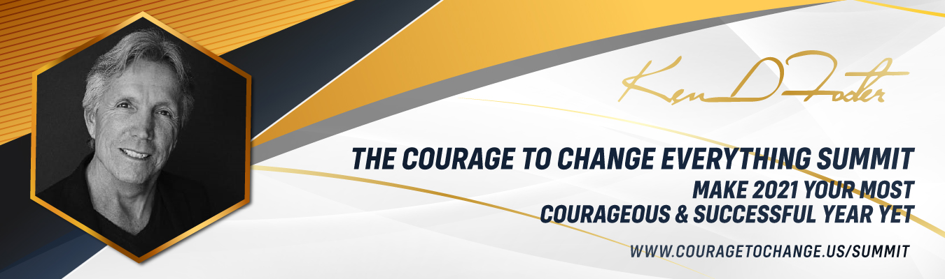
Invitation to Change Your Life in 2021, Courage to Change Virtual Summit, Jan 23rd

Hi (Your Name) here,
You have the opportunity right now to change a few things around, create a new vision of what’s possible for you and have your greatest year ever in 2021.
To that effect, I have created a Summit called: The Courage to Change Everything Virtual Summit featuring NY Times Best Selling Authors, Sharon Lechter, Dr. Ken Druck, Marci Shimoff, Jim Britt, Debra Poneman, and many more; Hollywood Star Natalie Popovich, Blue Angel Solo Pilot John Foley, Health Teacher Dr. Gabriel Cousens and high-profile experts in the fields of business, health, relationship, finance, and spirituality all committed to supporting you in up-leveling your business and life in 2021.
There is no charge for General Admission and I highly recommend you download the free eBook called The Energetic Clearing Technique™ when you register. You will clear disempowering beliefs, choices and actions that have kept you from living your life to the fullest.
If you are ready to have 2021 be your greatest year ever and generate more health, wealth, and happiness, I encourage you to register for the Courage to Change Everything Summit, let go of your limitations and get your copy today. Remember there is no charge for General Admission, although seating is limited.
Click here to receive the Energetic Clearing Technique™ eBook and get into the Courage Zone.
With Courage,
(Your Signature)
(Your Name)
(Your Title)

