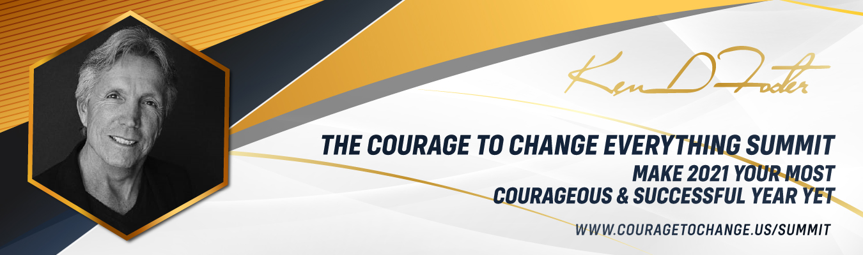
Subject: Courage to Change Virtual Summit, on Saturday

Hi (Your Name Here)
I know at this very moment you can achieve extraordinary feats by harnessing the unlimited power of courage. I know this because I have used courage to transform every part of my life and the lives of my clients.
Did you know that the results of applying daily courage have been nothing short of extraordinary. Why? Because your history does not have to be your destiny. You can tap into higher states of consciousness, and with courage, rewrite the scripts you are running in your mind.
To that end, I have brought together 45 of the most courageous people in know to help you Master every area of your business and life with The Courage to Change Everything Summit,
The Summit is featuring NY Times Best Selling Authors, Steven MR Covey, Sharon Lechter, Dr. Ken Druck, Marci Shimoff, Bill Treasure, Debra Poneman, and many more; Hollywood Star Natalie Popovich, Blue Angel Solo Pilot John Foley, Health and Life Style teacher Dr. Gabriel Cousens, Publicists Jill Lublin and Michelle Nicholson, International explorer Werner Berger and high profile experts In the fields of business, health, relationship, finance, and Health and Life Style all committed to supporting you in up-leveling your business and life in 2021.

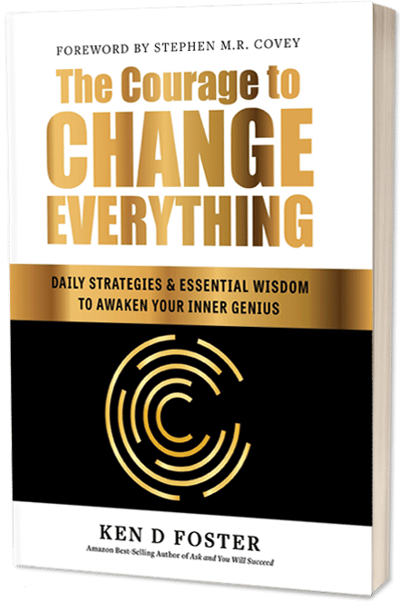
This Summit is designed exclusively for those experiencing any of the following:
- Your income is stagnant or declining.
- You often feel frustrated and powerless.
- You make choices you later regret.
- You keep putting your dreams on hold.
- You feel less than or even superior to others.
- You lack energy or enthusiasm.
- You pretend everything is okay, even when it really isn’t.

IT’S TIME TO REDEFINE WHAT IS POSSIBLE FOR YOU
If you are ready to have 2021 be an amazing year and generate more health, wealth, and happiness, then sign up for the summit today. Complimentary tickets are available, but seating is limited.

Get your Ticket now! http://www.CouragetoChange.us/Summit
Live With Courage,
Your Name Here

